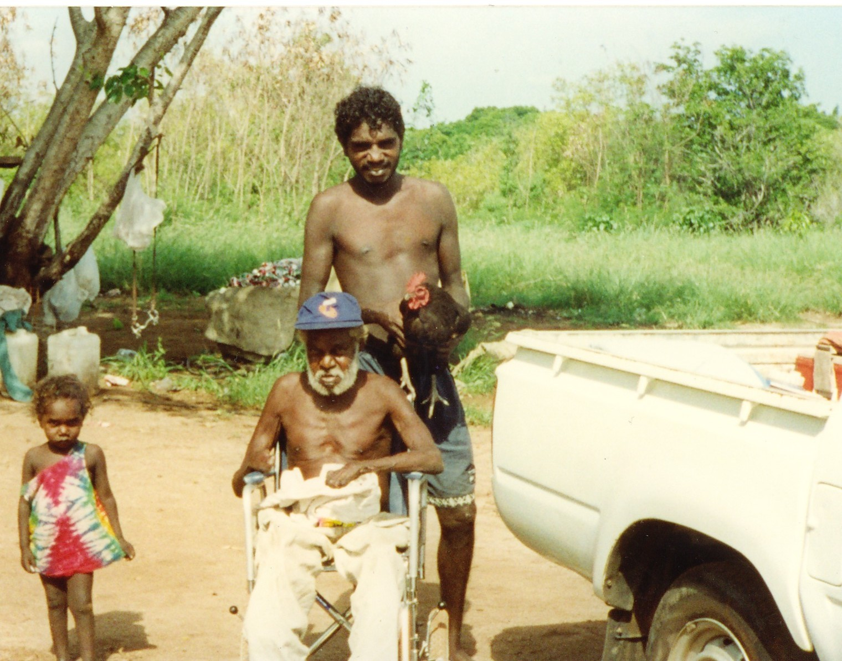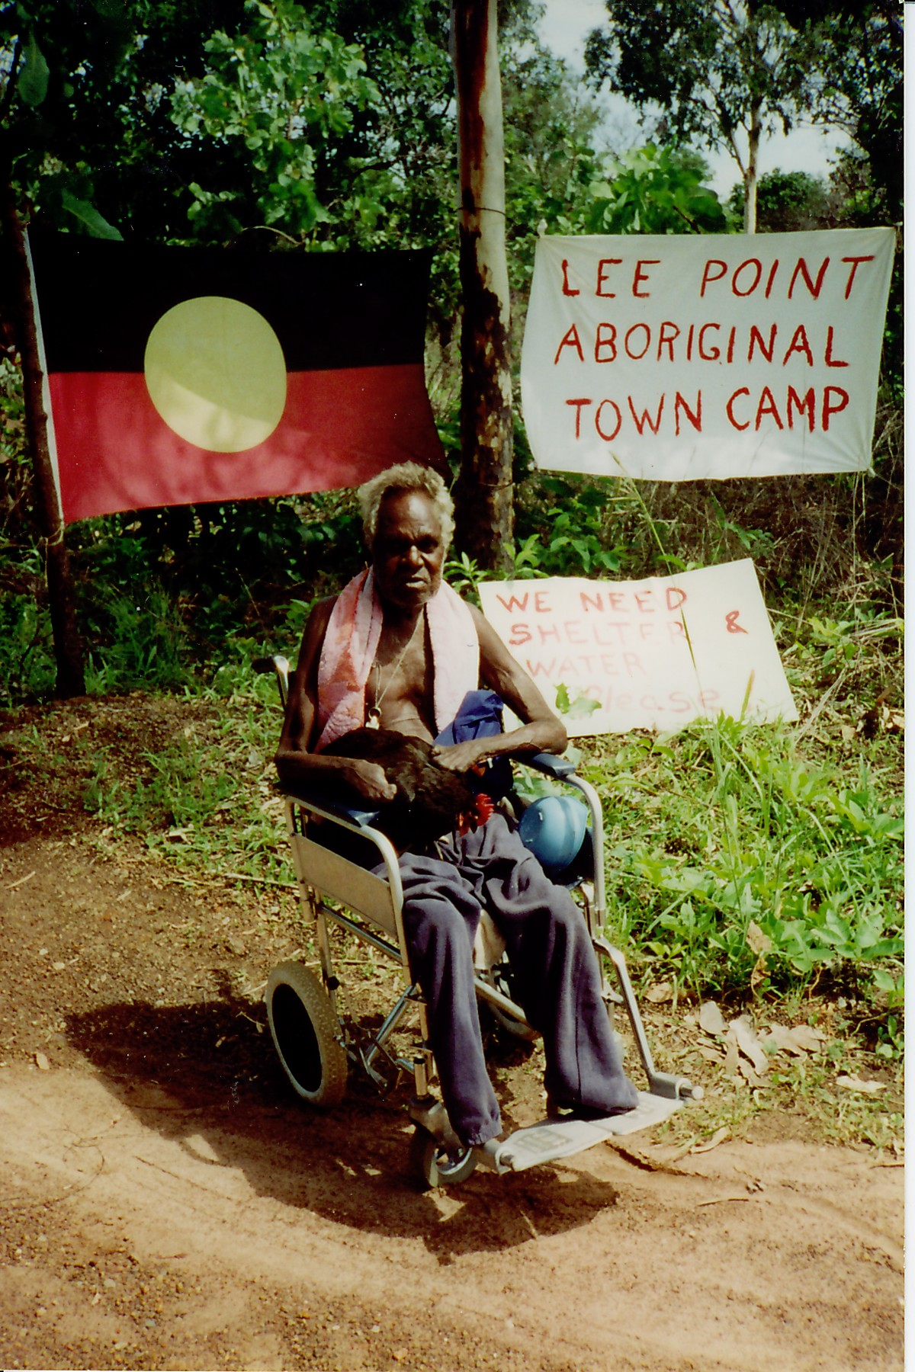
One day, Bob said, ‘Take me back to Lee Point.’ The police said that Lee Point was ‘Crown Land,’ but Bob was not afraid. That November, he set up another camp.

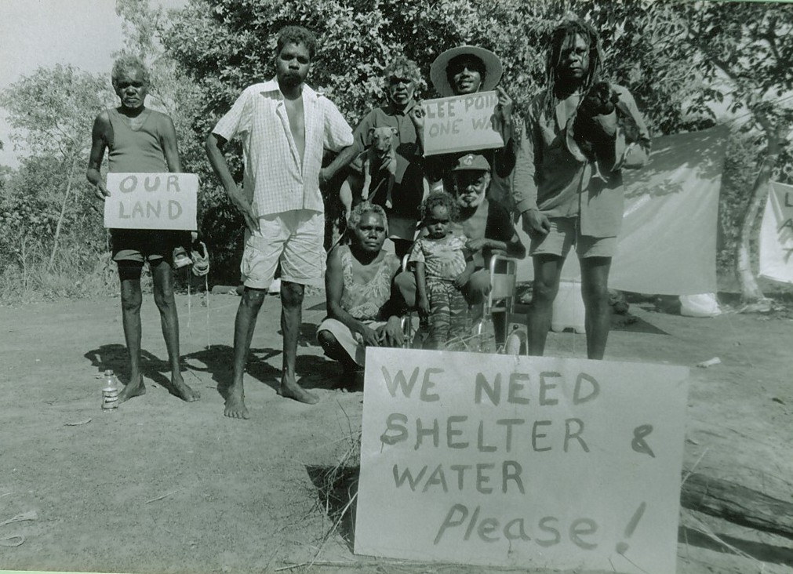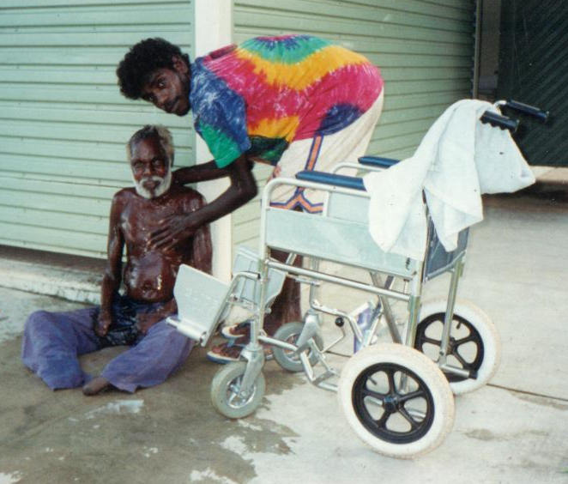

Bob and his friends were in the newspaper. At Lee Point they could use the shower and the toilets. Bob liked to be beside the sea. ‘I will stay here until I die,’ he said.

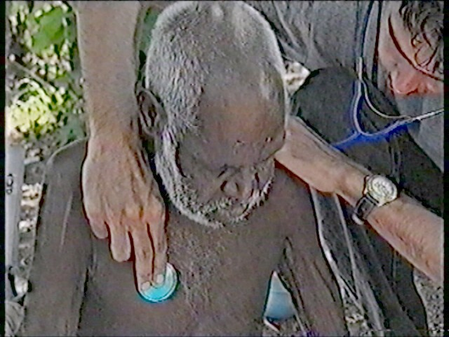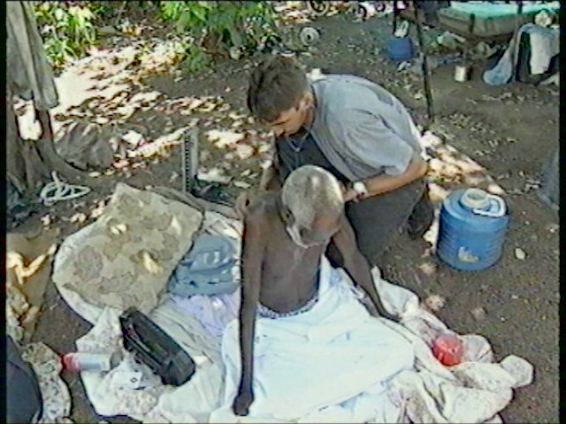

The Northern Territory Government did not care that Bob was sick. For a while the Anti-Discrimination Commissioner, Dawn Lawrie, stopped the politicians from evicting Bob and the other Lee Point campers. Bob lived at his protest camp through the heavy January rain. The doctor came to see him, but Bob still refused to move.

